**ESP: Building your glossary**

# Figure 1: Standard entry in a good dictionary

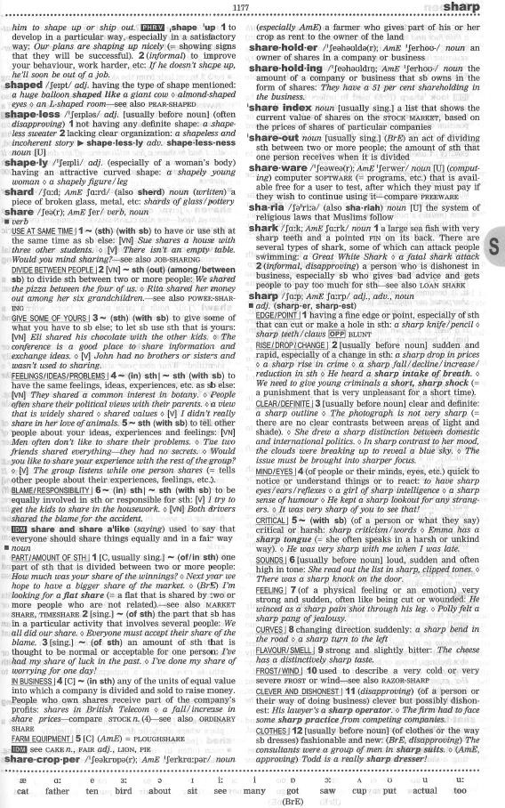

Vocabulary Development

# Figure 2: Identifying features of dictionary definitions

Work with a partner and label the information provided in the dictionary entry below.

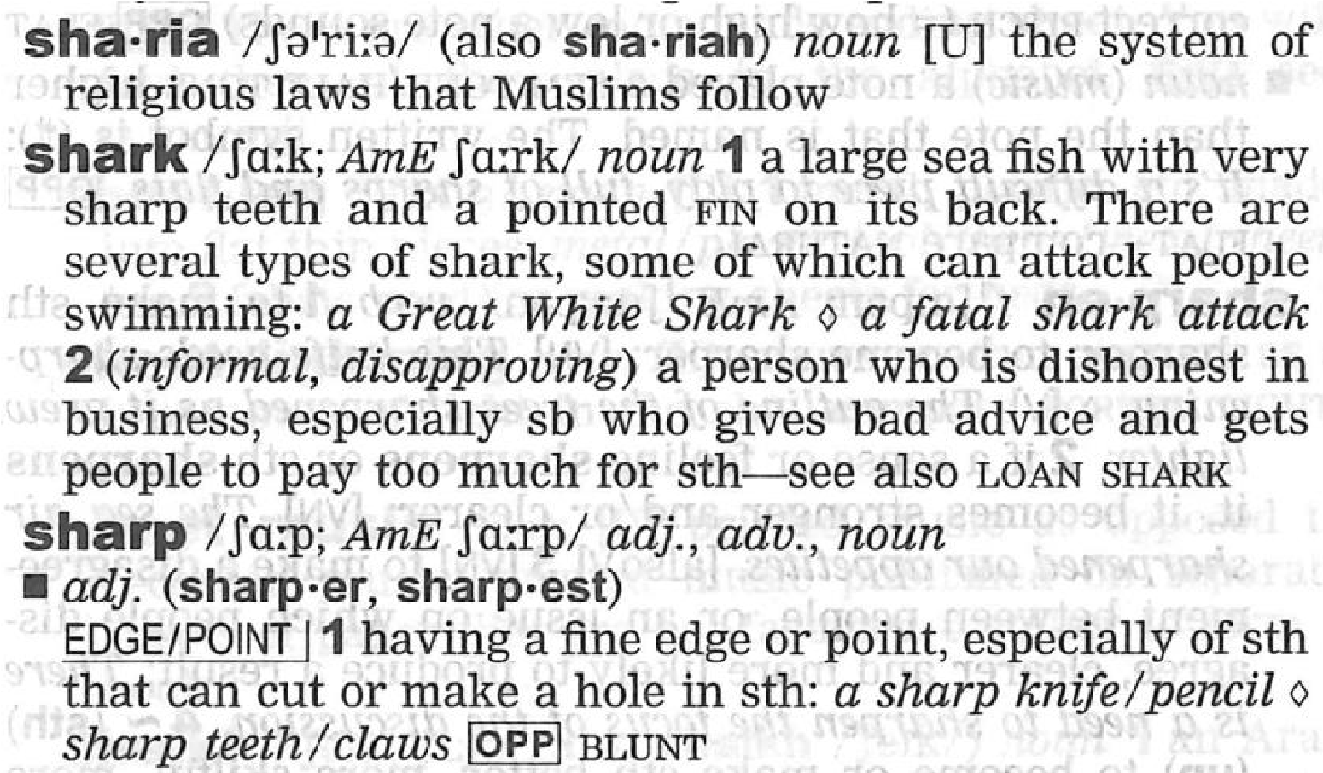

# Figure 3: A template for glossaries

Match the headings below to the correct column in the table. **Use all of the labels below** – the number of labels for each column is given in parenthesis.

|  |  |  |  |  |  |  |  |  |  |  |  |  |  |  |
| --- | --- | --- | --- | --- | --- | --- | --- | --- | --- | --- | --- | --- | --- | --- |
| *Form* |  | *Word* |  | *Visual* |  | *Pronunciation* |  | *Word-family* |  | *Definition* |  | *Context* |  | *Collocation* |

|  |  |  |  |
| --- | --- | --- | --- |
| **1.** ______________________________ (x 3) | **1.** ____________________________________________ (x 2) | **2.** ______________(x1) | **3.** ___________________(x 2) |
| shark (noun) | /ʃɑːk/ 1. a large sea fish with very sharp teeth and a pointed fin on its back. |  | A **great white shark** is believed to have killed a 31-year-old scuba diver on his honeymoon in Australia.    She was really out of her depth now and in **shark infested waters**. |
| moral (adjective) morality (noun)  *Antonym =* amoral (adjective) | /ˈmɒrəl/ 1. concerned with or relating to human behaviour, esp the distinction between good and bad or right and wrong behaviour: moral sense |  | I see absolutely no conflict between having **moral values** and running a profit making business.    Some form of **moral education** is vital to encourage pupils to develop attitudes of cooperation and concern for justice. |
| panic (noun) panicky (adjective) | /ˈpænɪk/ 1. a sudden overwhelming fear, with or without cause, that produces hysterical or irrational behaviour, and that often spreads quickly through a group of persons or animals.  2. an instance, outbreak, or period of such fear. |  | **Panic swept** through the crowd.    He felt a **rising panic** when he couldn’t find his keys |

Figure 4: Paper versus online dictionaries

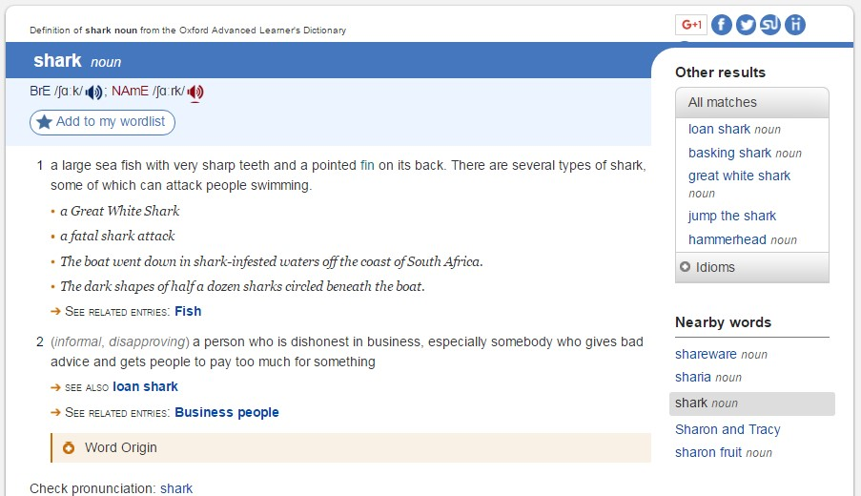

Online dictionaries and paper dictionaries both provide all of the information that you need to understand

any given word. The great advantage of a paper dictionary is that words are

listed in alphabetical order,

and you must scan through the book to find the word you are searching for. This provides an incidental

opportunity to learn other words you may have not known, nor were you searching for

–

this opportunity is

lost online. On t

he internet, you will be immediately taken to the definition you need: unrelated words are

omitted. A paper dictionary is slightly slower, but it has the great advantage of exposing you to many more

words.

Also

,

Engli

sh

-

to

-

English dictionaries are far

more effective than translation

-

dictionaries

at higher levels of

study, when fluency in the language is required.

***Paper Dict***

***ionary***

***Online Dictionary***



## Glossary

|  |  |  |  |
| --- | --- | --- | --- |
| Item / Form / Word Family | Pronunciation & Definition | Visual | Context & Collocations |
|  |  |  |  |
|  |  |  |  |
|  |  |  |  |
|  |  |  |  |
|  |  |  |  |
|  |  |  |  |
|  |  |  |  |
|  |  |  |  |
|  |  |  |  |
|  |  |  |  |
|  |  |  |  |

### TEMPLATE

|  |  |  |  |
| --- | --- | --- | --- |
| Item / Form / Word Family | Pronunciation & Definition | Visual | Context & Collocations |
|  |  |  |  |
|  |  |  |  |
|  |  |  |  |
|  |  |  |  |
|  |  |  |  |
|  |  |  |  |
|  |  |  |  |
|  |  |  |  |
|  |  |  |  |
|  |  |  |  |
|  |  |  |  |

TEMPLATE

Vocabulary Development